Tara Wilk

CENG 340 – lab 3

September 17, 2013

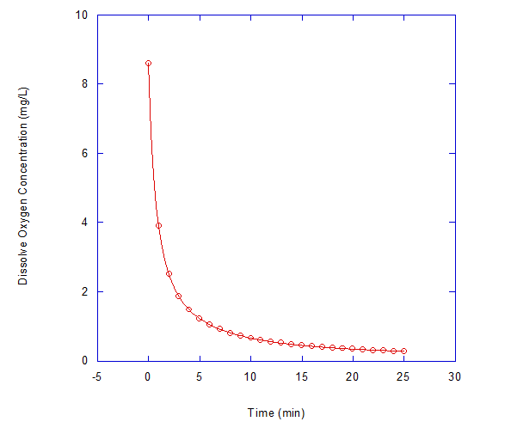

Figure 1. shows the dissolve oxygen concentration versus time. The reaction is second order because the relationship was best fit by Equation 4. The k value is 0.14005 L/(mg\*t).

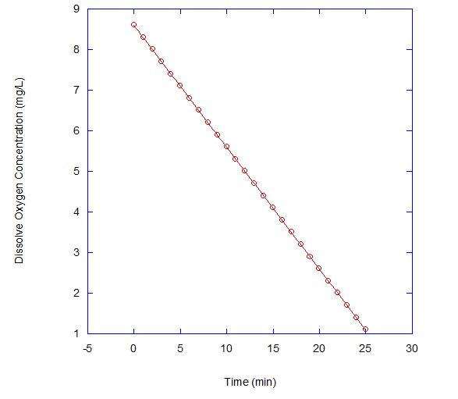

Figure 2. portrays the dissolve oxygen concentration versus time. The reaction is zero order due to the fact that data is best fit with Equation 2. The k value is 0.3 mg/(L\*t).

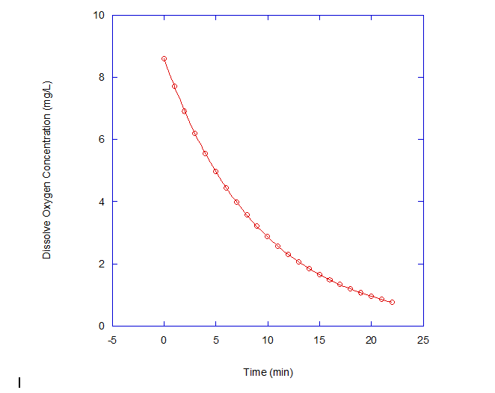

Figure 3. depicts dissolve oxygen concentration versus time. The reaction is first order because Equation 3 best fits the data points. The k value is 0.1101 1/t.